Set ports for listening:
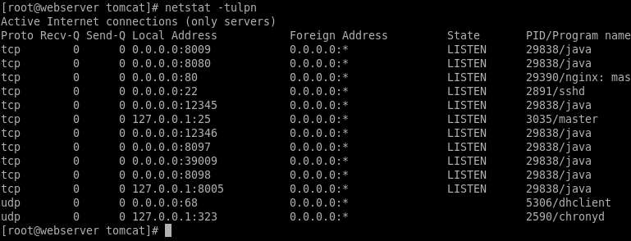
checks:
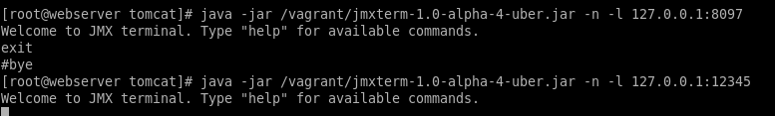
add host with jmx:
add items:

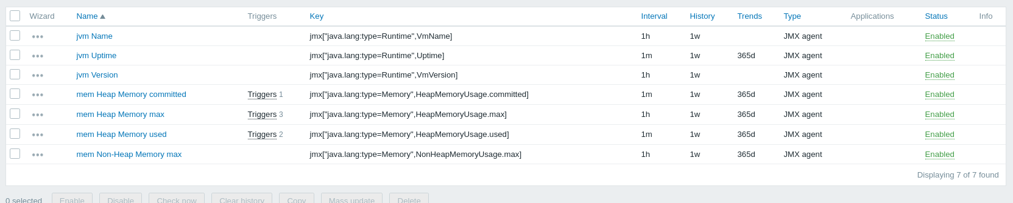
add some triggers:
